Configure ZTE MF622 USB Modem for All Service Provider

Here are a few step to configure your ZTE MF622 USB Modem. The modem can be configure for all service provider such as Celcom Broadband, Digi Edge, Maxis Broadband and U-Mobile.
1st Step:
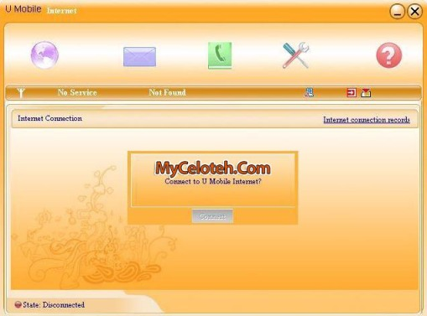
2nd Step:
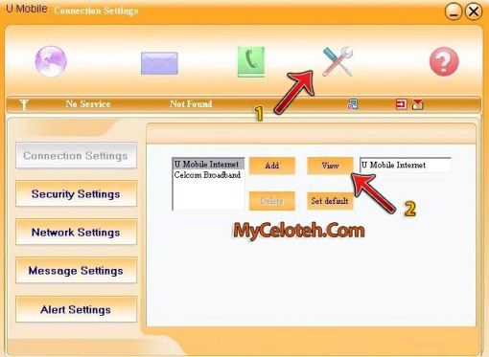
3rd Step:
Fill only Config Filename : Any name you want
Dialer Number : *99#
APN: For U-Mobile: my3g, For Celcom Broadband: celcom3g,
Maxis Broadband: maxisbb, For Digi: diginet
