DTS-HD Master Audio The method of extracting a voice in TMPGEnc Video Mastering Works5
In TMPGEnc5, since no imported speech which is recorded in DTS-HD Master Audio,
Let me show you how to capture in conjunction with other software.
■ prepare soft · TMPGEnc Video Mastering Works 5
· TsMuxeR ··· software to convert video and audio of m2ts files the sound of soft · eac3to ··· DTS-HD to or multiplexed or separated into AC3 format (I use the GUI version)
■ Installation of TsMuxeR TsMuxeR I will download and install from the site.
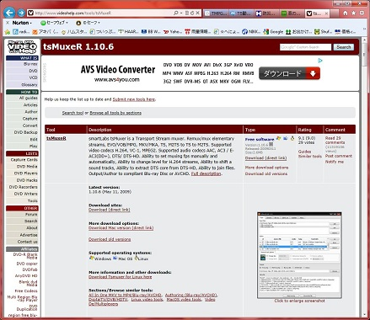
■ Installation of Eac3to Eac3to I will download and install from the site.
Download the eac3to.zip and EAC3toGUI.zip, and then copy the files in the eac3to.zip in the folder where you extracted the EAC3toGUI.zip.
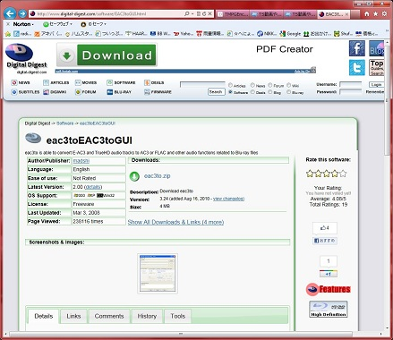
■ Use the speech separation tsMuxeR of m2ts files to separate the voice from the m2ts file
①tsMuxeR after startup, and then drag and drop the m2ts files to be separated 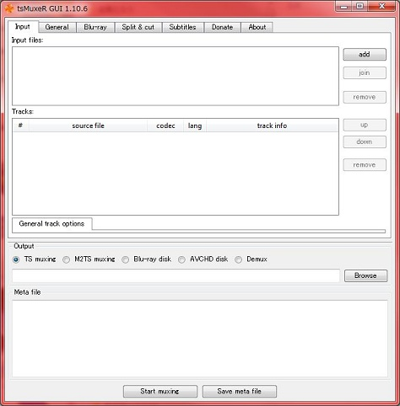
Codec from the ②Tracks is, and then select the folder of the selected output destination Demix in ③Output that you can check what is in DTS-HD 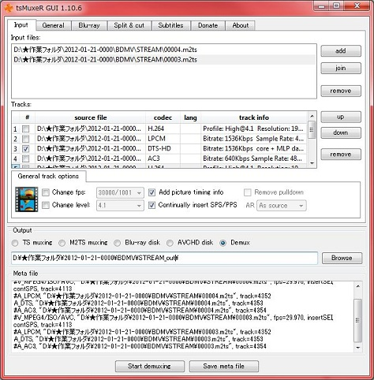
④ the user presses the "Start demuxing" button to output 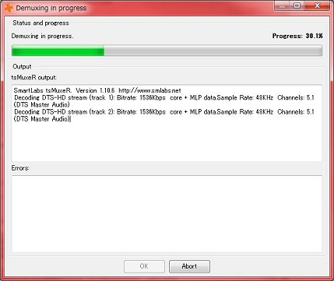
■ the DTS-HD file that you use extracted the conversion eac3to to AC3 format to convert to AC3 format
Specify the output destination to specify ②Destination file a DTS-HD file you just extracted ①Source file (perhaps it has been specified by default)
③ by pressing the "Convert" button, so please make sure that the ac3 file is generated at the output destination ※ to the specified folder it may not work properly when the Japanese are used,
Please change the name of the folder in single-byte letters that case

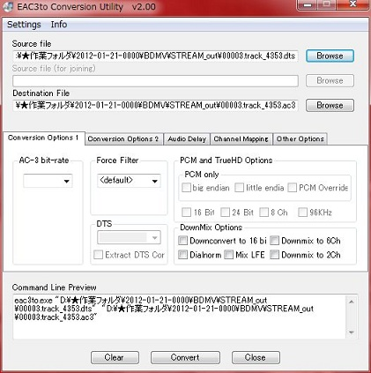
■ Creating a m2ts file (Synthesis of video and audio)
I will synthesize the ac3 format of audio files and video you just generated that were in the original m2ts file
You drag and drop the ① original m2ts file ② and then drag and drop the ac3 file generated earlier codec is H.264 from the ③Tracks, codec from among ④Tracks that you can check what is in AC3 pgs , you can check what lang is in jpn (not required if no)
Make sure the selected output destination M2TS muxing in ⑤Output
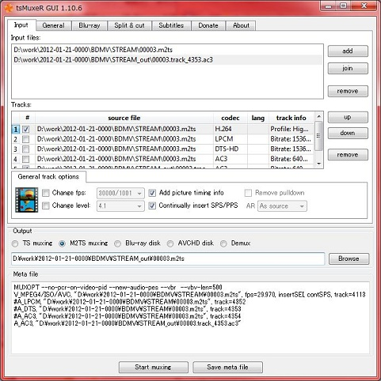
⑥ "Start demuxing" to output the depression and m2ts files button ※ Let patiently wait because it takes time to create.
In addition, the original m2ts file so significant burden to disk takes is recommended that you keep to the HDD.
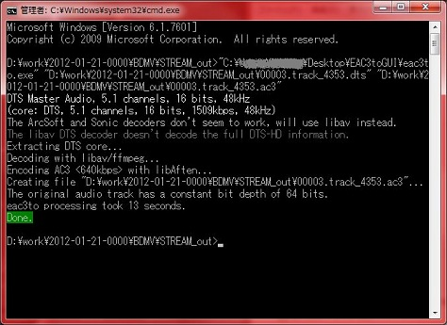
This I is the end.
After reads the output has been m2ts file in TMPGEnc Video Mastering Works 5,
Please be encoded in the required format.

