Tour and screenshots
When you run Partition Find and Mount, it locates all storage devices that are present in the system:
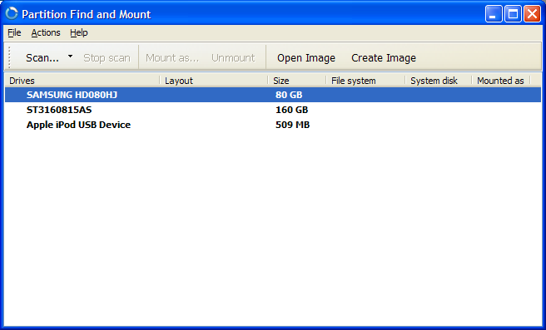
Let's assume we've lost a partition on our FUJITSU MPF3102AT hard drive. We simply select the hard drive from the list and click Scan.
After scan is complete, Partition Find & Mount lists all partitions it has found:
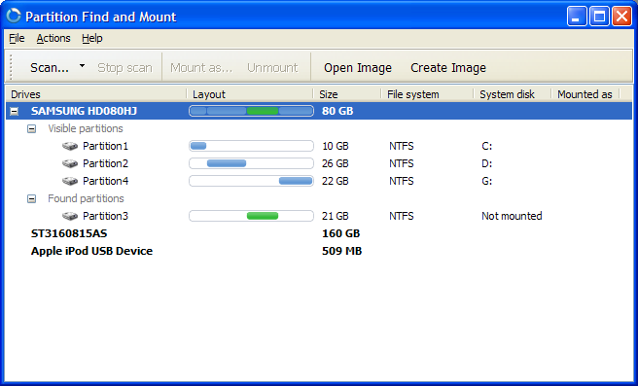
Now we have to mount our newly found partition. Partition Find & Mount allows to assign any drive letter to the partition; in this example we've chosen letter U.
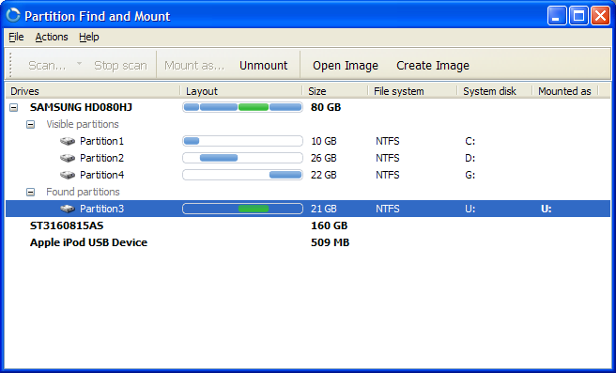
At this point we can open Windows Explorer and access the mounted partition like any other partition in the system. We can also save a binary image of the found partition or entire hard drive, and then scan and mount it at a later time!
We hope that you enjoy the process of recovering lost partitions with Partition Find & Mount. In case you experience any difficulties, please contact us.

